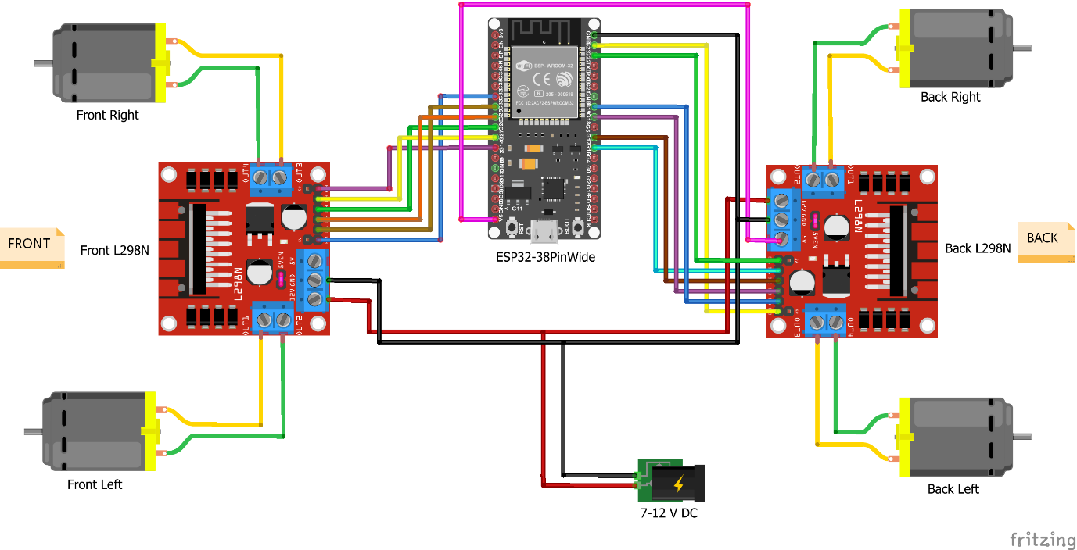**Components for Robot Car**

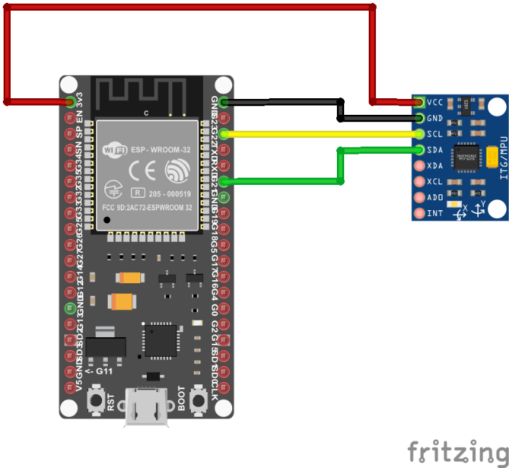

**Transmitter part:**

1. MPU6050
2. 5v battery(optional)
3. PCB

**Receiver robot car:**

1. ESP32 MODULE
2. Mecanum wheels or wheel
3. TT Gear motors (4 piece)
4. L298N motor driver module (2 Piece)
5. 7v-12v rechargeable battery
6. Micro USB female

**Components for ai:**

1. ESP32 MODULE
2. MIC for arduino mega
3. Speaker for arduino mega
4. power plug Arduino (barrel jack)

**Optional Components:**

1. ESP32-cam module
2. ESP32-MB micro usb